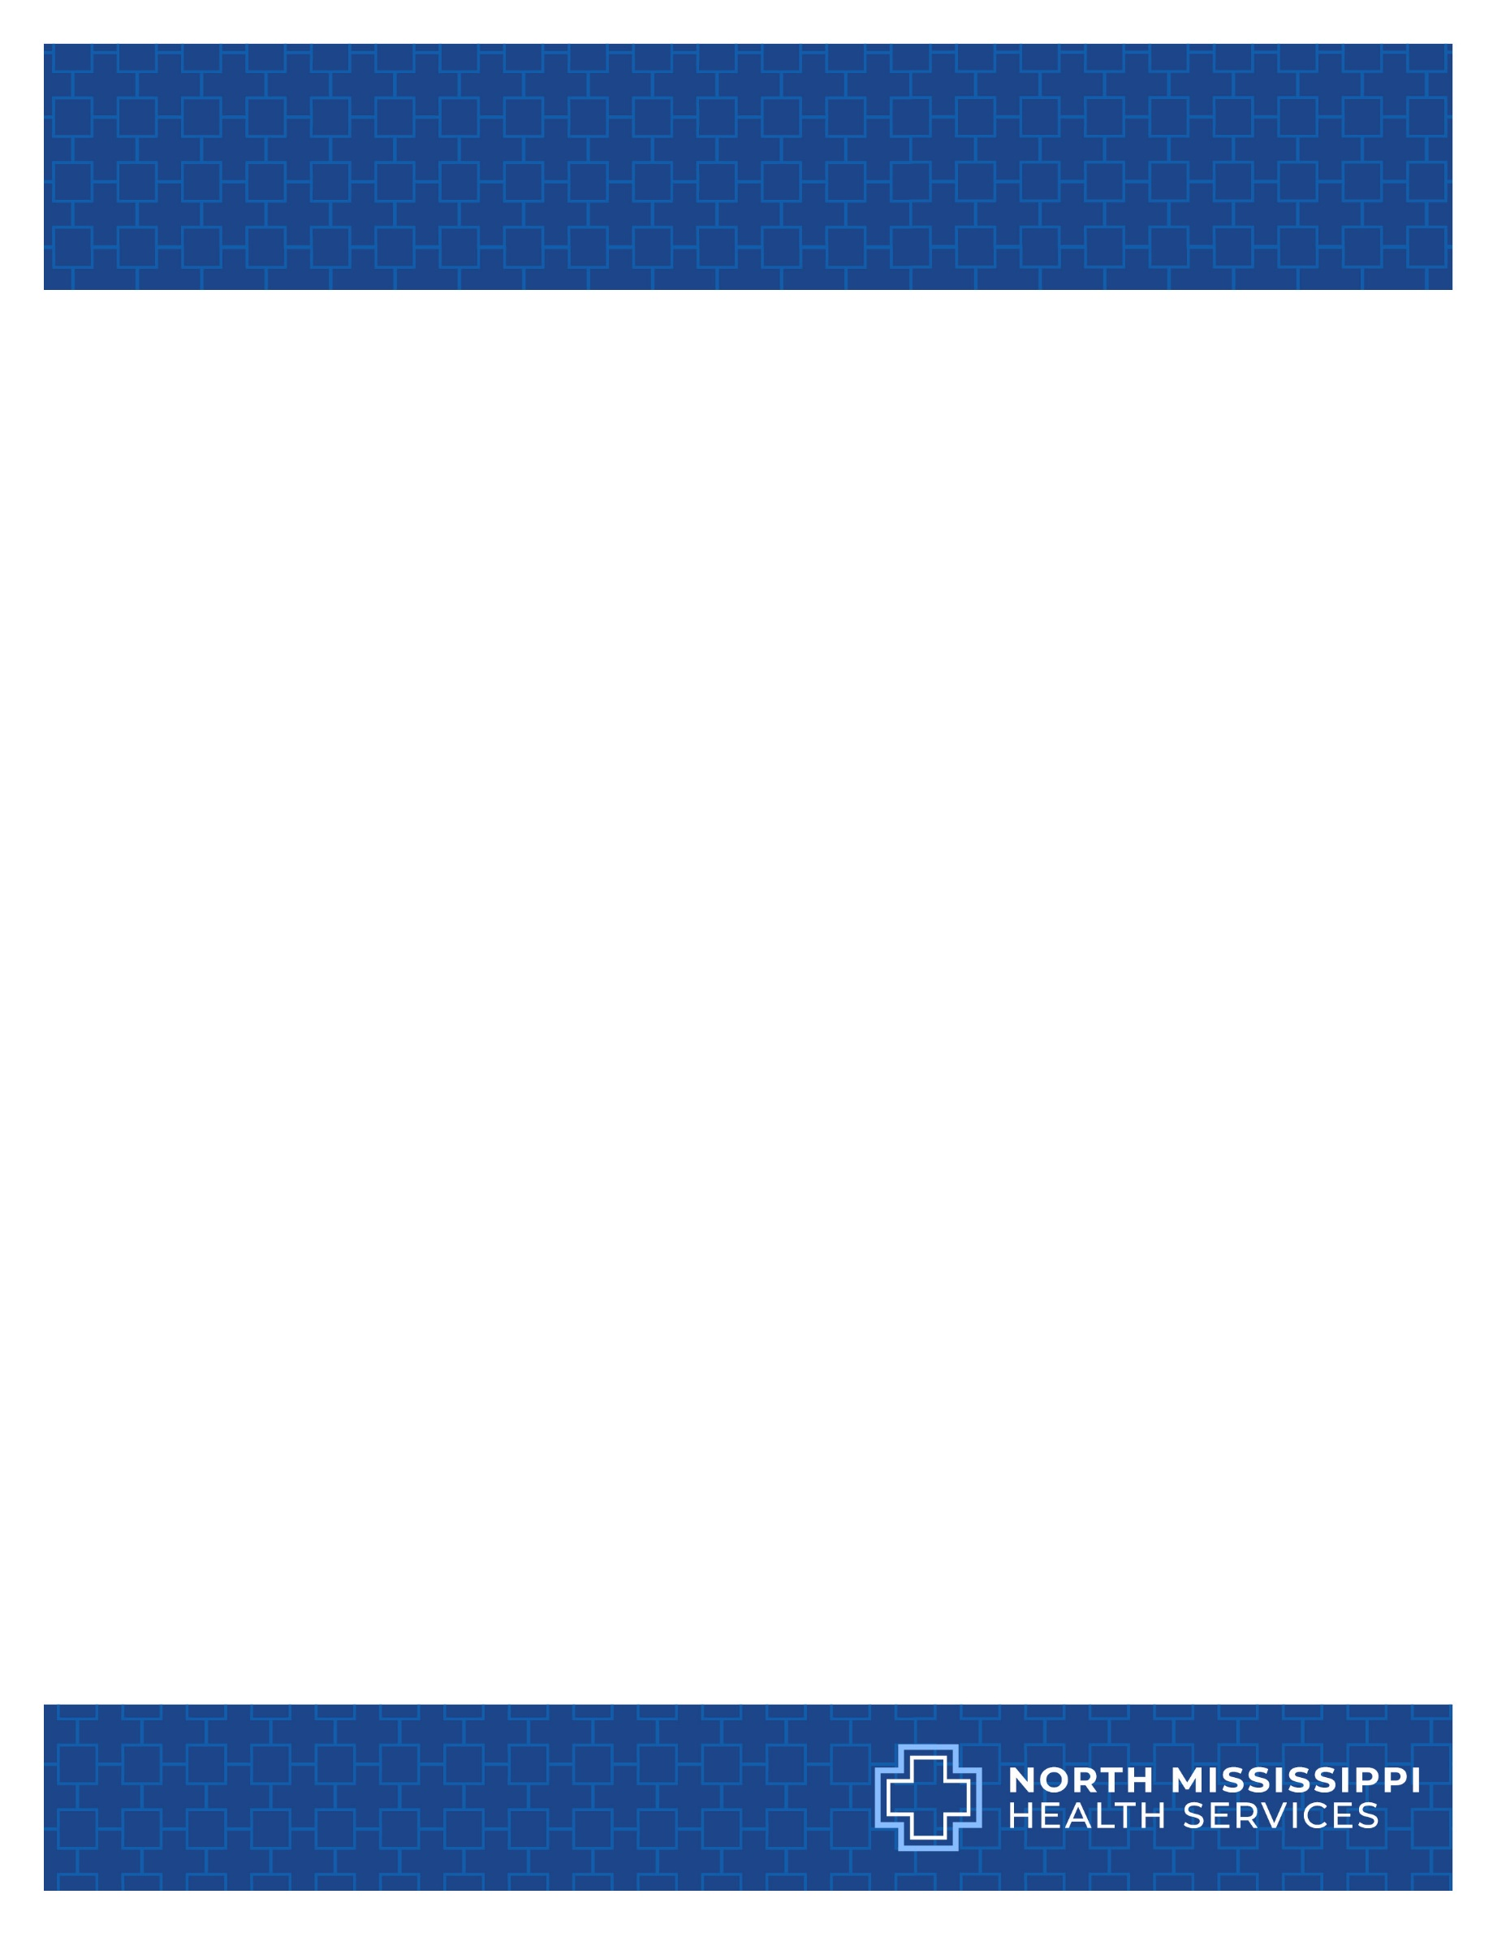**NMHS Grand Rounds:** *Effective Communication with Your Consultant at 2am – The Why and How*

**Presenters:** Stephen McAdory, MD, FACS, Surgery Associates Roger Williams, MD, FACC, Cardiology Associates of North MS

**May 9, 7:00-8:00AM NMHS Auditorium or**

[**Join the meeting now**](https://nam02.safelinks.protection.outlook.com/ap/t-59584e83/?url=https%3A%2F%2Fteams.microsoft.com%2Fl%2Fmeetup-join%2F19%253ameeting_ZjJmZGY5ZDAtMDk5Ni00YWMyLTkwMzQtZmVkMDMwNzRiNTlj%2540thread.v2%2F0%3Fcontext%3D%257b%2522Tid%2522%253a%25222ecc02fd-019c-441e-900c-f9437020fb9e%2522%252c%2522Oid%2522%253a%252201c9f459-6877-419e-87b5-97176b98dd6e%2522%257d&data=05%7C02%7CTMaxey%40nmhs.net%7Cd160222e3e214dd5389608dd8bf06cfd%7C2ecc02fd019c441e900cf9437020fb9e%7C0%7C0%7C638820586950688467%7CUnknown%7CTWFpbGZsb3d8eyJFbXB0eU1hcGkiOnRydWUsIlYiOiIwLjAuMDAwMCIsIlAiOiJXaW4zMiIsIkFOIjoiTWFpbCIsIldUIjoyfQ%3D%3D%7C0%7C%7C%7C&sdata=%2BKmvpit1vs2JUQfx6v%2FD5aTNta6DCWyhHge289aG%2Fow%3D&reserved=0)

**Meeting ID: 217 908 372 44**

**Passcode: BR3Ww9AN**

**Upon completion of this activity, Participants will:**

1. Understand the role of teamwork in providing safe effective patient care.
2. Facilitate the development of skills to effectively collaborate with a consultant.
3. Identify the key communication components necessary when calling a consultant.
4. Review effective and ineffective strategies for communication.
5. Review needs in being adept at discussing a consultant’s recommendations for patient care.

**Accreditation**

* The Mississippi State Medical Association is a member of the Southern States CME Collaborative (SSCC).  North Mississippi Medical Center is accredited by the SSCC to provide continuing medical education for physicians.

NMMC designates this Live Activity course for a maximum of 1.00 *AMA PRA Category 1 Credit(s)TM*. Physicians should only claim credit commensurate with the extent of their participation in the activity.

* NMMC is approved as a provider of nursing continuing professional development by the Mississippi Nurses Foundation, an accredited approver by the American Nurses Credentialing Centers Commission on Accreditation. This activity has been awarded 1.00 contact hour(s). CE#00192-EDII-2329.